This is sample text in the beginning of the file

I’m adding another body to this document and there is a picture to the left of the paragraph this time. I’m adding another body to this document and there is a picture to the left of the paragraph this time.

I’m adding another body to this document and there is a picture to the left of the paragraph this time.

I’m adding another body to this document and there is a picture to the left of the paragraph this time.

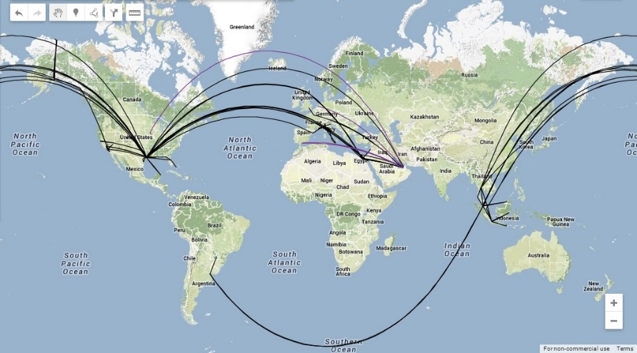I’m adding another body to this document and there is a picture to the left of the paragraph this time.

I’m adding another body to this document and there is a picture to the left of the paragraph this time.

I’m adding another body to this document and there is a picture to the left of the paragraph this time.

I’m adding another body to this document and there is a picture to the left of the paragraph this time.

I’m adding another body to this document and there is a picture to the left of the paragraph this time.

This is sample text in the end of the file